ASSIGNMENT 2: SOWMIYA T(111519106152)

Build a python code by assumming temperature and humidity values using random function .And write a condition to continuously buzz an alarm in case of high temperature.

Program:

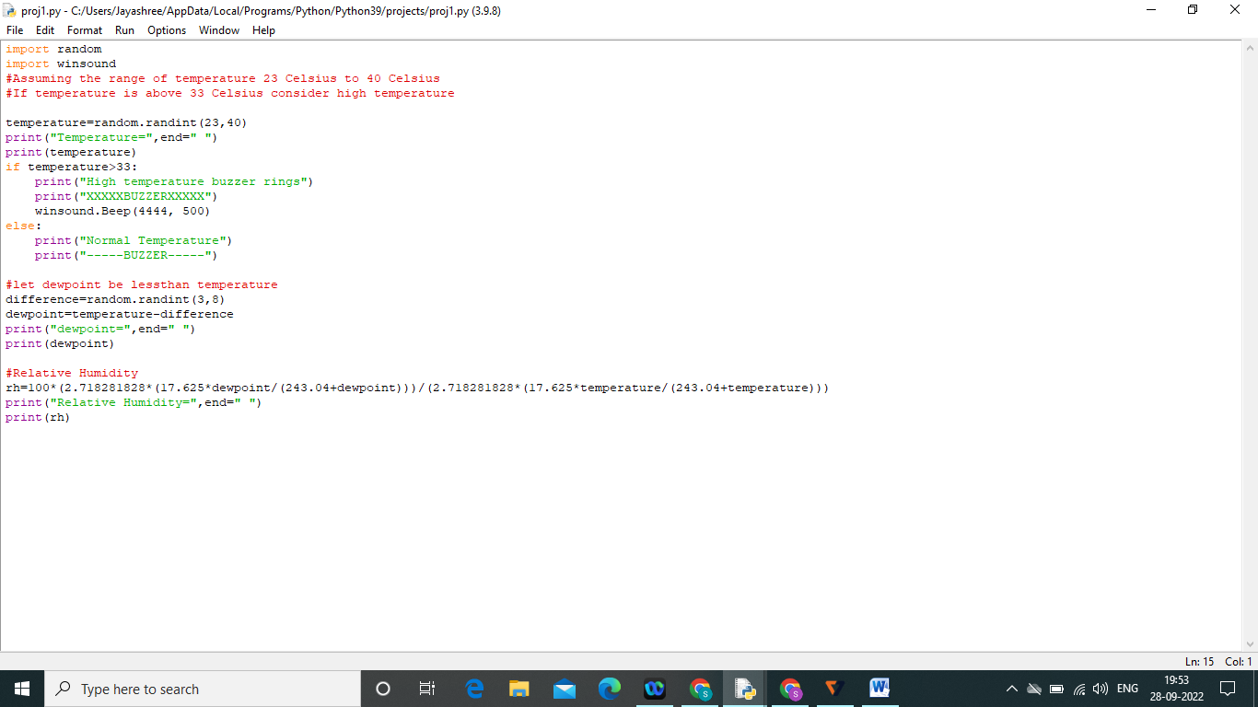

Output:

